Jack Berberian

CIS 245

1/26/2022

Getting Your Systems Set Up Pt 1 – Ubuntu

If you don’t have the files already

1. Go to <https://ubuntu.com/download/server> and select manual server installation.
2. Download Ubuntu Server xx.xx.x LTS somewhere accessible
3. Download and install the corresponding Virtual Box for your system from: <https://www.virtualbox.org/wiki/Downloads>

If you have your system ready

1. Go to Virtual Box and select the blue new button.

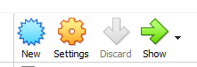

1. In the Create Virtual Machine dialog box, enter a VM name, select about 3000MB for memory, and select create a virtual hard disk now

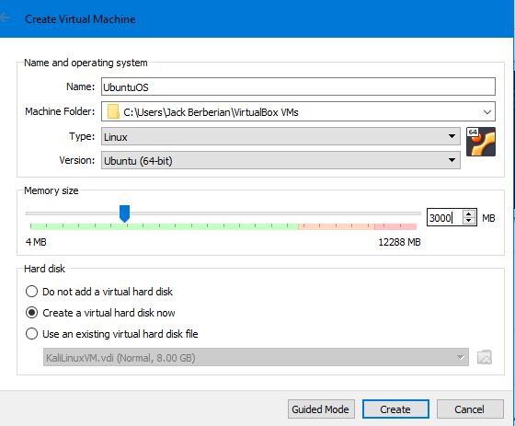

1. Leave the next page alone and press Create
2. Go to Settings, General, Advanced, and select Bi-Directional for the Shared Clipboard and Drag and Drop.

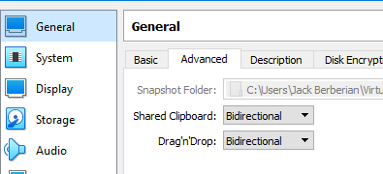

1. Go to System and unselect floppy, go to Processor and select 2.

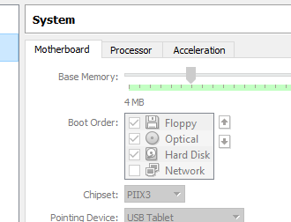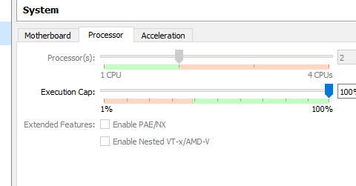

1. Go to Storage and under Controller IDE, press the empty drive, to the right of the optical drive, select the CD and press choose a disk file, and the navigate to the server file.

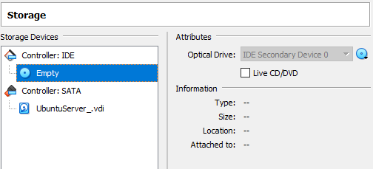

1. Go to Network, Adapter 1 and then select Bridged Adapter.

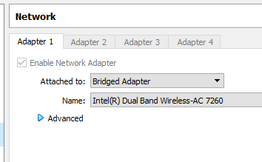

1. Then press OK and then the green start arrow to begin the installation.

Installation

1. Once the installation boots up, select your desired language and press enter.

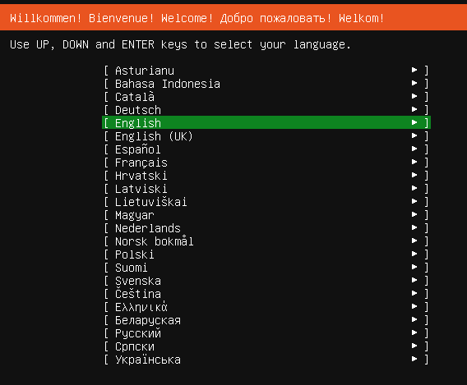

1. On the next page, select Continue without updating

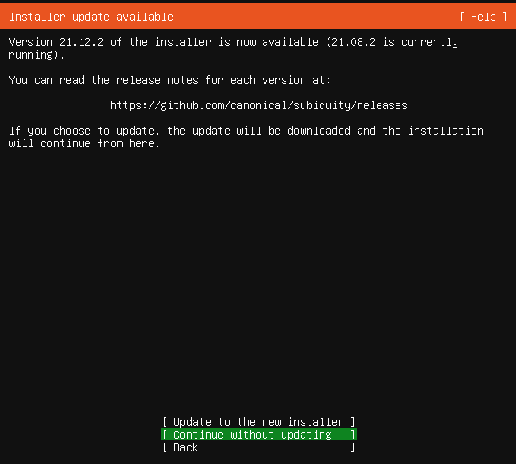

1. Done to confirm the keyboard configuration

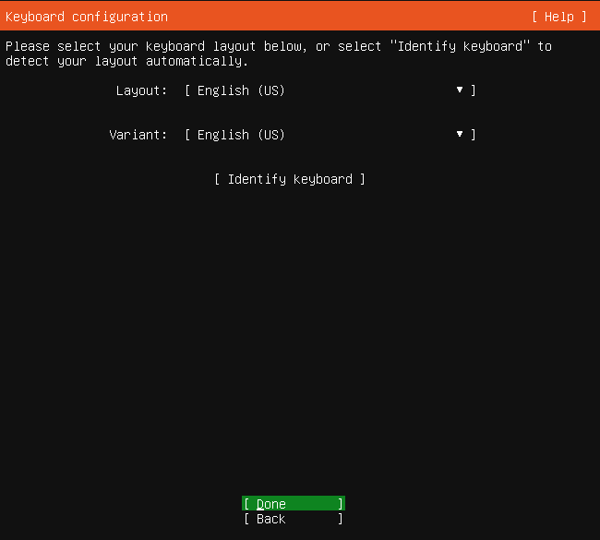

1. Done to confirm the network configuration

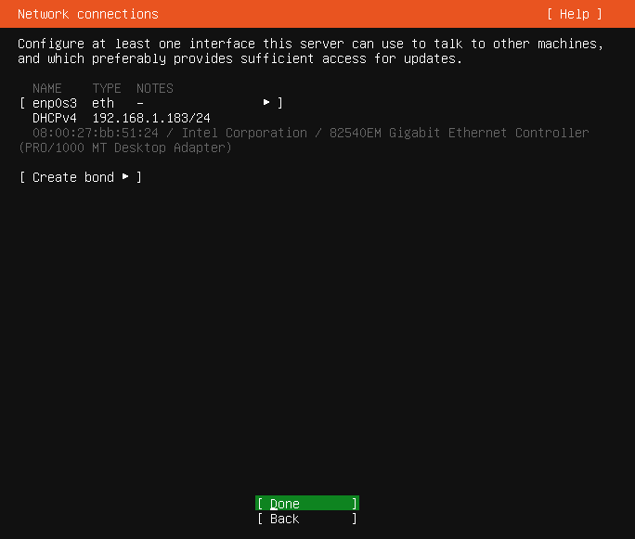

1. Done to skip configure proxy

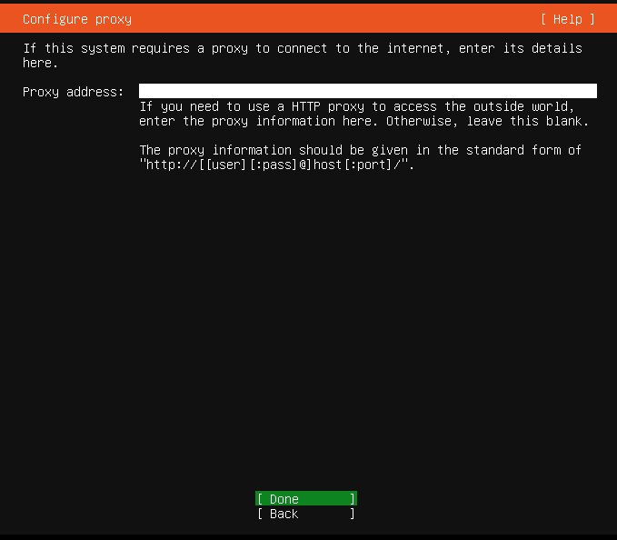

1. Enter to select the Ubuntu archive mirror

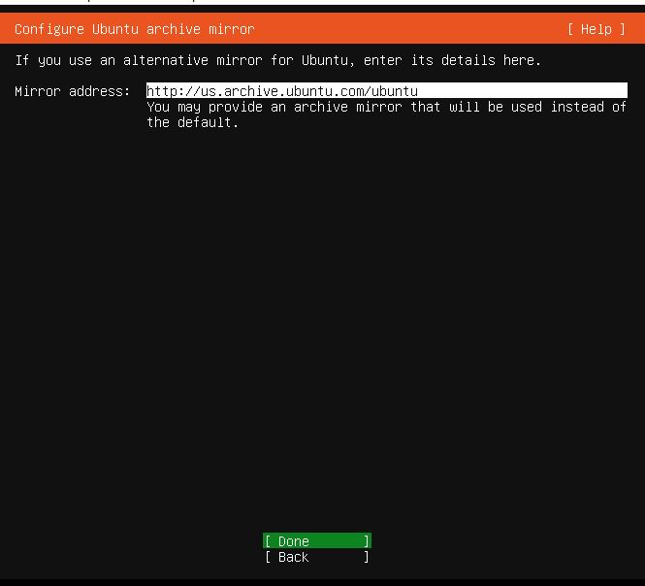

1. Enter on the Guided Storage configuration page to select Use an Entire Disk which is the VBOX HARDDISK

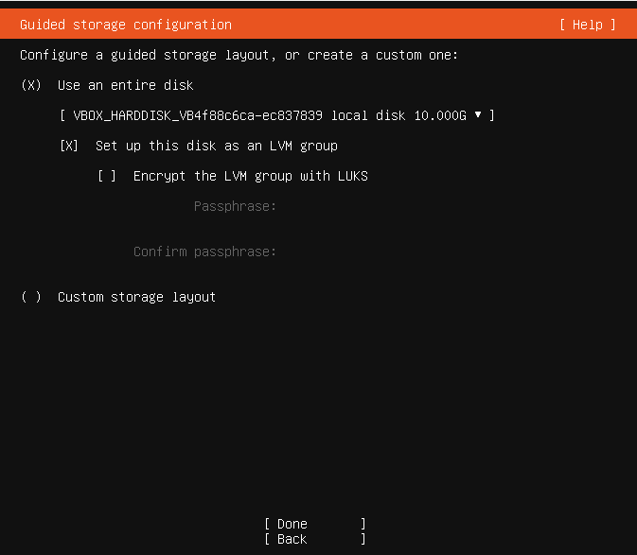

1. Done on the Storage Configuration page

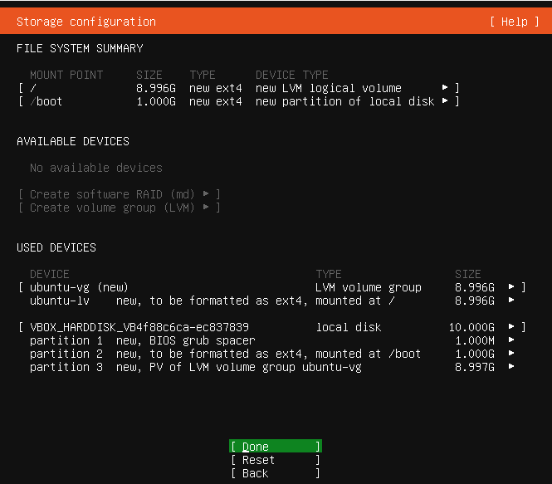

1. Press Continue on the Confirm Destructive Action dialog box to continue.

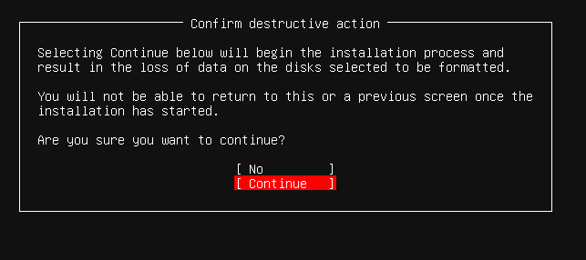

1. Then on the profile setup page, enter your name, server name, username and password

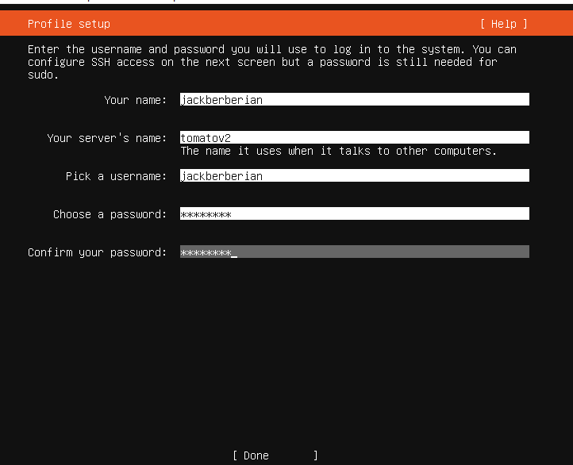

1. On the SSH setup page, press enter to select the Install OpenSSH server option and then go to the next step

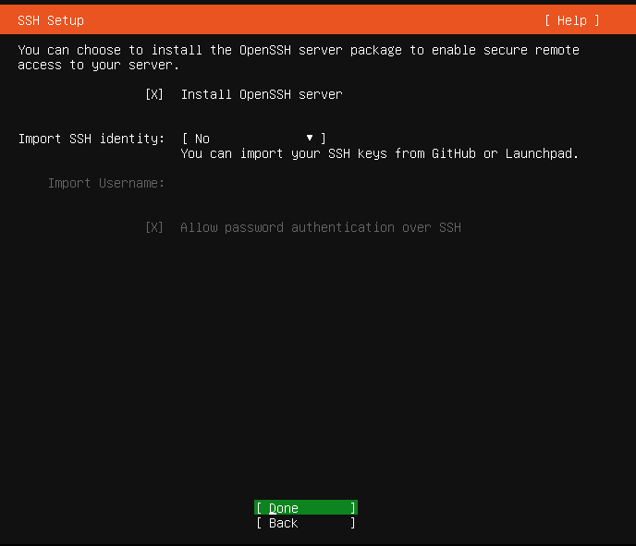

1. On the Featured Server Snaps, press done to begin the system installation.

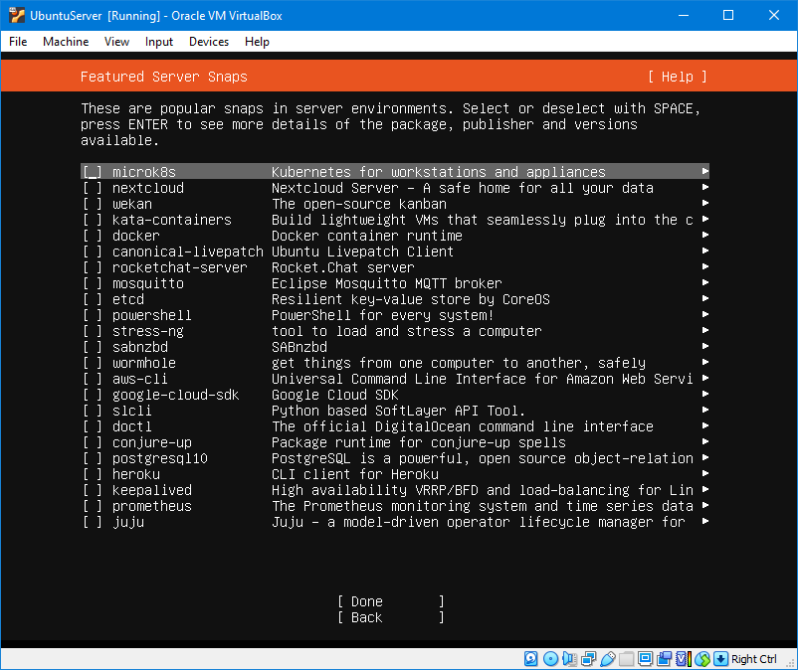

1. When prompted, you can enter either cancel update and reboot or wait until the update is finished and then reboot. You can update later if you skip it.

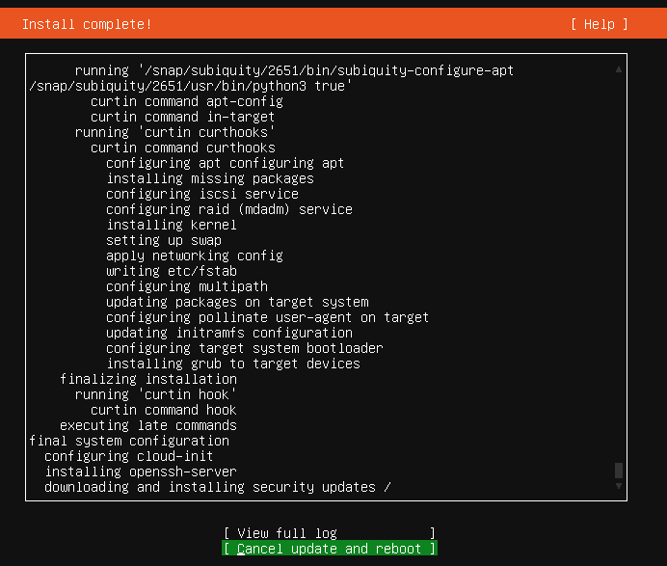

1. When an error message shows up to remove the installation media, press enter and wait for installation to process.
2. Once installation stops, press enter and enter your username and password when prompted.
3. Congratulations! You’ve installed Ubuntu Server.

How to Install Samba to share Files

1. Boot virtual machine and then login.
2. Enter sudo apt update and enter your password when prompted.

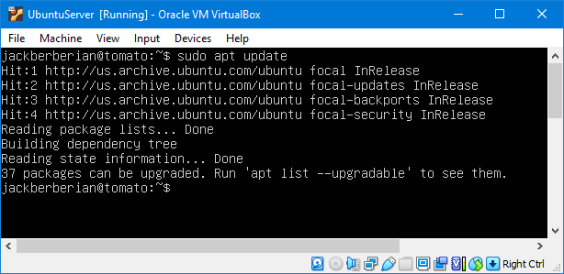

1. Then sudo apt install samba -y (the y will just skip prompt to install samba)

If not installed already, it’ll begin to install.

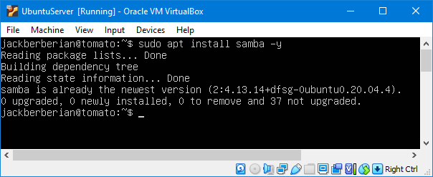

1. Then make a directory that will be shared using samba. You can use mkdir /home/yourusername/sambashare

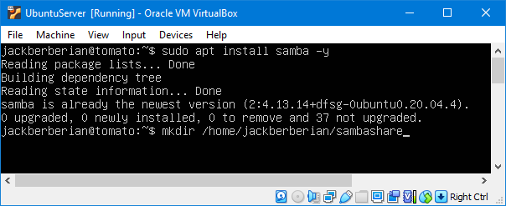

1. Then enter sudo nano etc/samba/smb.conf and at the end of the file, enter the location where your samba server is. Press Ctrl X to quit and then enter to save.

[samba share]

Comment = Samba Share

Path = /home/username/sambashare

Read only = no

Browseable = yes

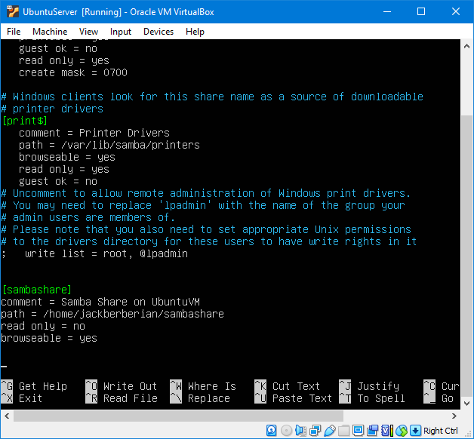

1. Enter sudo service smbd restart so the server restarts and uses the changes.

Setting up User Account for Samba

1. Enter sudo smbpasswd -a (yourusernamecreatedearlier)

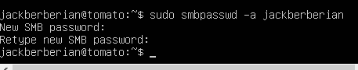

1. Congratulations, you’ve installed Samba!
2. To view files from your samba server share, go to File Explorer on Windows, enter //(hostname)/ into the menu bar and when prompted for you password, it’ll take you to the share.

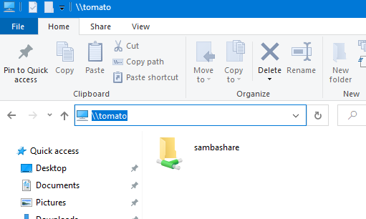

A short document saying what I’ve included in my installs, including any software I’ve added and any configurations I’ve changed.

The only additional software that I added was Samba to share files, nothing else. All configurations are detailed above.